NLP Chatbot Development using Dialogflow

**Software Requirements Specification**

Version 1.0



**Group Id: F24PROJECT8DE28 (bc210415622)**

**Supervisor Name: Abdullah Qamar (**[abdullah.qamar@vu.edu.pk](mailto:abdullah.qamar@vu.edu.pk)**)**

**Revision History**

|  |  |  |  |
| --- | --- | --- | --- |
| **Date (dd/mm/yyyy)** | **Version** | **Description** | **Author** |
| 19/11/2024 | 1.0 | Chatbots are increasingly becoming integral to industries such as customer service, e-commerce, healthcare, and education. In this project, students will develop a chatbot using Google Dialogflow, an NLP-powered conversational interface. The chatbot should address a specific business need by automating customer interaction, providing relevant responses, and enhancing user experience. | Bc210415622 |
|  |  |  |  |
|  |  |  |  |
|  |  |  |  |

**Table of Contents**

1. Scope (of the project)
2. Functional Requirements Non Functional requirements
3. Use Case Diagram
4. Usage Scenarios
5. Adopted Methodology
6. Work Plan (Use MS Project to create Schedule/Work Plan)

**SRS Document**

1. **Scope of Project:**

The scope of the project includes the development of intelligent NLP-based chatbots using Dialogflow to meet specific business needs in industries such as customer service, e-commerce, healthcare, and education.

The chatbots will automate important tasks such as answering frequently asked questions, providing product recommendations, scheduling appointments, and providing educational guidance.

It will use the dialogflow's natural language understanding function to accurately process the user's input, identify intention, pull out entity and generate related answers.

Chat robots will support the placement of platforms such as sites, mobile applications and social media many channels to ensure smooth integration with external systems, such as API or databases for dynamic and personalized interactions.

* **Intended Functionalities:**
* Table Reservation
* Menu Navigation
* Place order
* Track order
* Track reservation
* **Specific Task the System Will Accomplish:**
* Easy Customer Interaction
* Better Operations
* Personalized Experience
* **Project Overview:**

The project developed a Google Dialogflow chatbot that can automate tasks such as FAQs, recommendations, and scheduling in industries such as customer service and education.

Using NLP for accurate, context-aware responses provides user-friendly, scalable, and effective solutions across platforms.

* **Scope Boundaries:**

**In scope:** NLP chatbot development.

**Out scope:** complex conversation, advanced AI.

1. **Functional and Non-Functional Requirements:**

[**Functional requirements**](https://www.altexsoft.com/blog/functional-requirements/) are product features or functions that developers must implement to enable users to accomplish their tasks. So it’s essential to make them clear both for the development team and the stakeholders.

**Nonfunctional requirements** are not related to the system's functionality but rather define howthe system should perform. They are crucial for ensuring the system's usability, reliability, and efficiency, often influencing the overall [user experience](https://www.altexsoft.com/blog/user-experience-ux-design-in-software-product-development-how-to-create-exceptional-product-value/).

* + **Functional requirement:**
* **Table Reservations:**
* **Activity:** Enable the customer to check table available or not for desired date, time and party size.
* **Action:** The user provides detail about date, time and no. of guests. The chatbot will check availability and then process confirmation.
* **Order Placements:**
* **Activity:** Customers should be able to place order from the chatbot for takeaway or dining in.
* **Action:** After reviewing the menu, users can select items to order and the chatbot should collect their selections, confirm the order.
* **Menu Navigation:**
* **Activity:** A complete menu with item descriptions, prices, and exclusive deals should be presented to users by the chatbot.
* **Action:** The user has the option to ask the chatbot questions regarding particular menu items. The requested information, including any current sales or exclusive offers, is provided by the chatbot in response.
* **Track order:**
* **Activity:** Inquiries about the order, what’s the order status pending or preparing.
* **Action:** The user can ask about their order status, whether it's pending or being prepared, and the chatbot can respond based on the order status, indicating if it's pending or in preparation.
* **Track Reservation:**
* **Activity:** Inquiries about the reservation , what’s the reservation status pending or preparing.
* **Action:** The user can ask about their reservation status, whether it's pending or waiting, and the chatbot can respond based on the reservation status, indicating if it's pending or in waiting.
  + **Non-Functional Requirement:**
* **Scalability:**
* **Activity:** The system should be able to handle increased traffic, particularly on weekends or holidays when demand is at its peak.
* **Action:** Make sure the foundational system is scalable to handle unexpected spikes in user activity. Use cloud-based hosting with autoscaling features, for instance.
* **Security:**
* **Activity:** The chatbot should protect user data, particularly private data like payment preferences and contact information
* **Action:** Encrypt communication channels, abide by data protection regulations and make sure user data is handled and stored securely.
* **Usability:**
* **Activity:** The chatbot interface should be user-friendly and easy to navigate.
* **Action:** Create a conversational flow that is easy to follow so that the chatbot can comprehend user inquiries and reply in a way that is engaging and natural.
* **Reliability:**
* **Activity:** The chatbot should be available 24/7 with minimal downtime.
* **Action:** Use monitoring tools and a dependable hosting service to identify and address issues quickly. The system's continued operation will be guaranteed by routine backups and recovery procedures.
* **Performance:**
* **Activities:** The chatbot should respond to user queries within 2-3 seconds.
* **Actions:** Optimization of the backend processing**,** response caching where necessary, and making sure the server or cloud architecture can support numerous users at once without experiencing noticeable delay

1. **Use Case Diagram(s):**

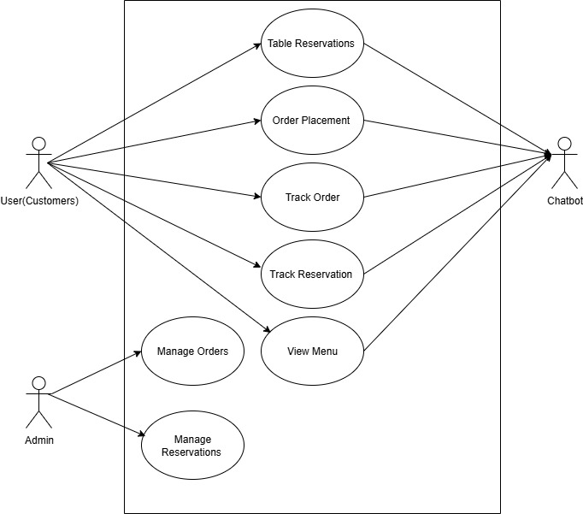

1. **Usage Scenarios:**

|  |  |  |  |  |  |  |  |
| --- | --- | --- | --- | --- | --- | --- | --- |
| **Use Case**  **Title** | **Use case Id** | **Description** | **Alternative**  **Paths** | **Pre-**  **Condition** | **Post-**  **Condition** | **Actors** | **Exception** |
| **Make Reservations** | UC-1 | Customer books a table using the chatbot. | Suggests alternate slots for unavailable times. | Customer provides valid details. | Reservation confirmed, notification sent. | Customer | System fails to confirm availability |
| **View Menu** | UC-2 | Customer browses the menu through the chatbot. | Notify customer if menu is under maintenance. | Menu data is available. | Menu displayed successfully. | Customer | Menu fails to load. |
| **Selection/**  **Confirmation Order** | UC-3 | Customer places an order for selected menu items. | Suggest alternative items if some are unavailable. | Customer is logged in. | Order confirmed, details recorded. | Customer | Invalid payment or network failure. |
| **Customer Support** | UC- 4 | Customer contacts chatbot for support regarding orders/issues. | None. | Chatbot is functional | Issue resolved or escalated to admin. | Customer | Chatbot fails to understand query. |
| **Process Reservations** | UC-5 | Chatbot processes the reservation request made by the customer. | Suggests alternative slots for unavailable reservations | Customer details are valid. | Reservation confirmed. | Chatbot | System fails to check availability |
| **Provide Menu** | UC-6 | Chatbot provides menu categories and items. | Notify the customer if menu data is temporarily unavailable | Menu data exists in the system. | Menu provided successfully. | Chatbot | Database error or missing records. |
| **Confirm Orders** | UC-7 | Chatbot processes the customer's order. | Suggest substitutions for unavailable items. | Items are in stock. | Order processed and saved in system. | Chatbot | Inventory fails to sync. |
| **Provide Customer Support** | UC-8 | Chatbot handles customer support requests. | Forward unresolved queries to the restaurant admin. | Chatbot is online. | Support query resolved or escalated. | Chatbot | Query misinterpretation. |
| **Manage Reservations** | UC-9 | Admin oversees and modifies reservations made by customers. | Notify customer of any updates. | Admin is logged into the system | Reservation details updated. | Restaurant  Admin | Reservation record not found. |
| **Manage Orders** | UC-10 | Admin manages order processing and ensures accurate updates. | Notify customers about order status changes. | Admin is authenticated | Order details updated in the system. | Restaurant  Admin | Order record missing or system crash. |
|  | | | | **Author** | | **F24PROJECT8DE28** | |

1. **Adopted Methodology**

The Restaurant Chat Bot was developed using a hybrid software development strategy that used the Waterfall strategy for structured planning and the VU process method for iterative improvements. While keeping a clear phase sequence, our hybrid method allows us to adapt to evolving requirements and input throughout the development process.

* **Waterfall Methodology**:  
    
  A logical and linear approach to software development is the Waterfall Methodology. It is one of the most traditional and ancient paradigms in software engineering. This concept suggests that the development process proceeds in a waterfall-like fashion as it moves progressively through several stages.
* **Diagram:**

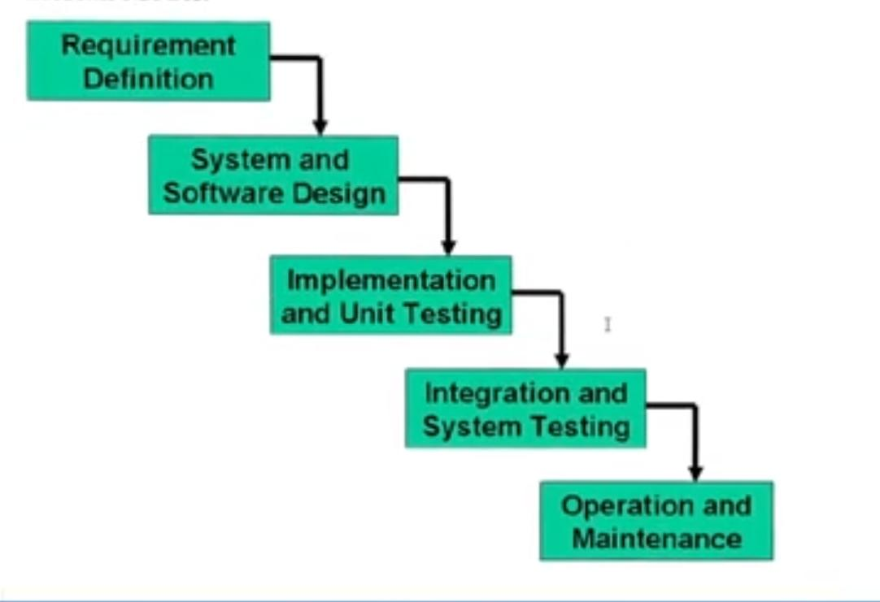

* **VU Process Model:**

This is the combination of Waterfall and Spiral model. In this model each stage of waterfall is preceded by identification of alternatives and risk analysis and followed by evaluation and planning for next phases

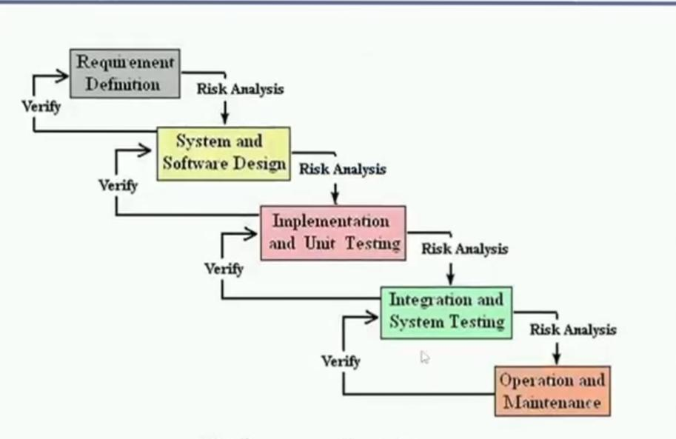

1. **Work Plan (Use MS Project to create Schedule/Work Plan):**

